What Drives House Prices in South Wales?
A Data-Driven Analysis of 135,000 Property Sales (2020–2025)

Independent Research Project – By Raymond Xie
June 2026 | R Programming & Data Analysis

Executive Summary
This report presents a statistical analysis of residential property sales across South Wales between 2020 and 2025, drawing on 135,069 transactions from the UK Land Registry. By combining this data with the Welsh Index of Multiple Deprivation (WIMD) 2019 and ONS postcode lookups, the analysis examines how property type, geographic location, deprivation level and time interact to determine house prices.
The central finding is profound: a gap of more than £200,000 exists between the average price of homes in South Wales's most and least deprived neighbourhoods. Property type is the single strongest predictor of price, while Cardiff and Monmouthshire command the largest location premiums in the region. A linear regression model using four variables: property type, district, deprivation rank and year, explains 52.5% of the variation in house prices.

1. Introduction
South Wales presents a particularly interesting housing market to analyse. Within a relatively compact geographic area, it contains one of the UK's fastest-growing capital cities (Cardiff), post-industrial valley communities with persistently high deprivation, rural market towns, and coastal areas. This diversity makes it an ideal case study for understanding how multiple converging factors drive residential property values.
This project was undertaken as an independent data analysis exercise using R, covering the full data pipeline from raw data acquisition and cleaning through to exploratory analysis, visualisation and predictive modelling. The research question guiding the analysis was: which variables have the strongest influence on residential property prices in South Wales, and by how much?

2. Data Sources
Three datasets were combined to produce the analytical dataset used in this report:

2.1 UK Land Registry Price Paid Data
The primary dataset is the Land Registry's Price Paid Data, which records every residential property transaction registered in England and Wales. The dataset covers the period January 2020 to June 2025 and was filtered to twelve South Wales local authority districts. It includes sale price, transaction date, postcode, property type (detached, semi-detached, terraced, flat) and whether the property was newly built. After filtering for South Wales and removing outliers (prices below £10,000 and above £2,000,000), the dataset contained 135,069 records.

2.2 Welsh Index of Multiple Deprivation (WIMD) 2019
The WIMD is the Welsh Government's official measure of relative deprivation. It assigns a rank to each of Wales's 1,909 Lower Super Output Areas (LSOAs) based on indicators across eight domains, including income, employment, health, education, access to services, community safety, physical environment and housing. A rank of 1 indicates the most deprived LSOA in Wales, while a rank of 10 indicates the least deprived. The overall WIMD rank was used as a continuous deprivation variable in this analysis.

2.3 ONS National Statistics Postcode Lookup (May 2025)
Because the Land Registry data contains postcodes, but the WIMD operates at LSOA level, a postcode-to-LSOA lookup from the Office for National Statistics was used to bridge the two datasets. This allowed each property transaction to be matched to its corresponding LSOA and, therefore, its WIMD deprivation rank.

3. Methodology

3.1 Data Cleaning and Preparation
Several data cleaning steps were required before analysis could begin:
- The date column in the Land Registry data contained timestamp data (e.g. "2020-07-03 00:00:00"), which required the extraction of the date component before conversion to a proper date format.
- Properties categorised as type "O" (Other) were removed, retaining only standard residential categories: Detached (D), Semi-detached (S), Terraced (T) and Flat (F).
- Price outliers were removed: 7,554 records fell outside the £10,000–£2,000,000 range and were excluded as likely non-market transactions or data anomalies.
- Postcodes were standardised by removing spaces before matching to the ONS lookup file, and all three datasets were merged using LSOA codes as the common key.

3.2 Variables Used
The following variables were selected for the regression model:
- Property Type — categorical variable (Detached as baseline category)
- District — categorical variable representing the local authority area (Blaenau Gwent as baseline)
- WIMD Rank — continuous variable from 1 (most deprived) to 1,909 (least deprived)
- Year — categorical variable capturing annual price trends (2020 as baseline)

3.3 Analytical Approach
The analysis followed a standard exploratory-to-inferential pipeline. Exploratory charts were produced first to understand the data's distributions and relationships. A multiple linear regression model was then fitted using R's built-in lm() function, with sale price as the dependent variable. Model fit was assessed using the adjusted R-squared statistic, and individual variable significance was evaluated at the p < 0.05 level.

4. Findings

4.1 Price Trends Over Time (2020–2025)
Average house prices in South Wales rose sharply between 2020 and 2022, climbing from approximately £198,000 to £232,000, a rise of around £34,000 in just two years. This reflects the well-documented post-COVID housing boom driven by the "race for space," low interest rates and stamp duty relief. Prices then plateaued through 2022–2023 as the Bank of England raised interest rates aggressively, before resuming an upward trajectory in 2024 and 2025. By 2025, the average South Wales property was selling for approximately £246,000, a total increase of nearly £50,000 over the five-year period.
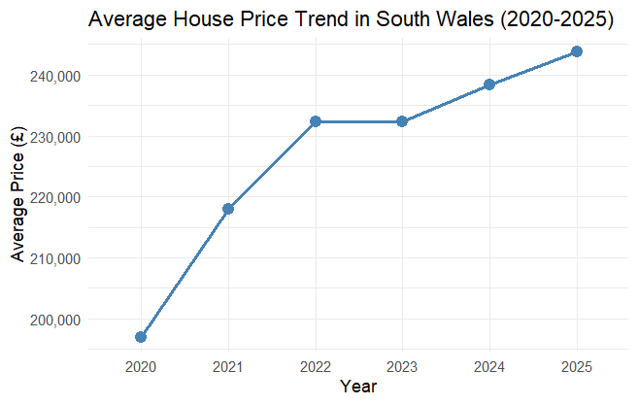
[Chart: Average House Price Trend in South Wales 2020–2025]

4.2 Price by Property Type
A clear price hierarchy exists across property types. Detached homes command the highest prices, with a median significantly above all other types. Flats and terraced homes cluster at the lower end, with relatively tight price distributions reflecting the more standardised nature of these properties.
The regression model quantifies these gaps precisely:
- Semi-detached homes sell for £127,400 less than detached on average
- Terraced homes sell for £161,800 less than detached on average
- Flats sell for £231,900 less than detached on average — the largest single price differential in the entire model
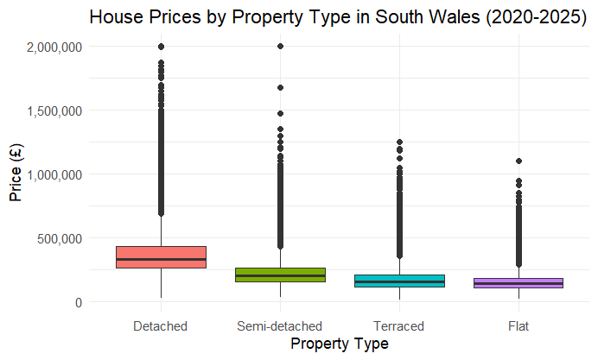
[Chart: House Prices by Property Type in South Wales 2020–2025]

4.3 Price by District
Monmouthshire is the most expensive district in South Wales, with average prices exceeding £330,000. Its semi-rural character, proximity to the English border and appeal to Bristol and Cardiff commuters drive premium prices. Cardiff follows closely at around £295,000, reflecting its status as the Welsh capital with strong employment and amenities. At the other end of the scale, Blaenau Gwent records the lowest average prices at around £140,000, less than half of Monmouthshire's average. The valley districts of Merthyr Tydfil, Rhondda Cynon Taf and Neath Port Talbot also sit at the lower end, reflecting their higher levels of deprivation and more limited economic opportunities.
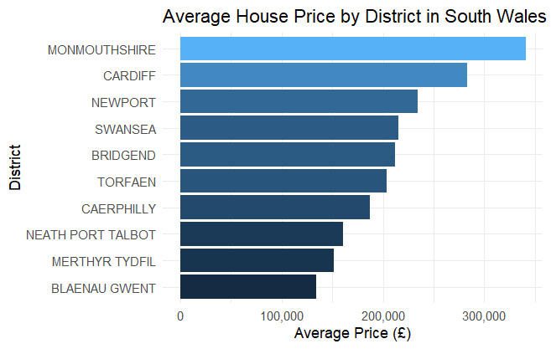
[Chart: Average House Price by District in South Wales]

4.4 The Deprivation Effect
The relationship between deprivation and house price is one of the most visually compelling findings of this analysis. When properties are grouped by their WIMD decile (1 = most deprived 10%, 10 = least deprived 10%), a near-perfect staircase pattern emerges. Average prices rise consistently from approximately £155,000 in the most deprived decile to over £355,000 in the least deprived, a gap of more than £200,000.
The regression model estimates that each one-rank improvement in WIMD rank (moving toward less deprivation) adds £59.40 to a property's value. Across the full range of 1,909 LSOA ranks, this translates to a total deprivation premium of approximately £113,000, making deprivation the second-most impactful continuous variable in the model after property type.
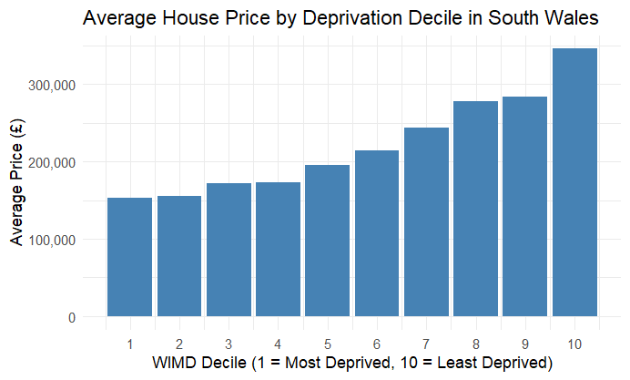
[Chart: Average House Price by Deprivation Decile in South Wales]

4.5 Regression Model Results
The multiple linear regression model achieved an adjusted R-squared of 0.5249, meaning the four variables together explain 52.5% of the variation in house prices across South Wales. This is a strong result for a housing model that uses only area- and property-level variables, without access to property-specific features such as number of bedrooms, floor area, or condition.
Key model findings:
- All property type variables are highly statistically significant (p < 0.001)
- WIMD rank is highly significant (p < 0.001), confirming deprivation as a genuine price driver
- All year variables are significant, confirming real annual price growth beyond inflation
- Merthyr Tydfil is the only district whose price effect is not statistically significant once deprivation is controlled for, suggesting its pricing is fully explained by deprivation levels rather than any independent location effect
- The actual vs predicted price scatter plot shows a strong diagonal cluster around the line of perfect prediction, with greater variance at higher price points, a typical pattern in housing models
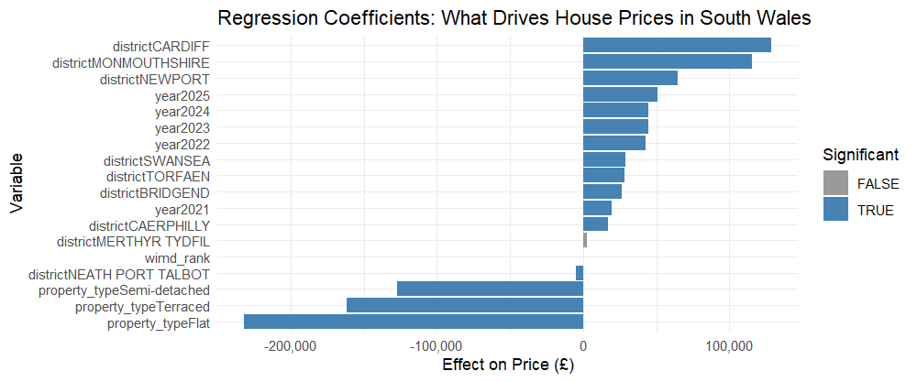
[Chart: Regression Coefficients — What Drives House Prices in South Wales]
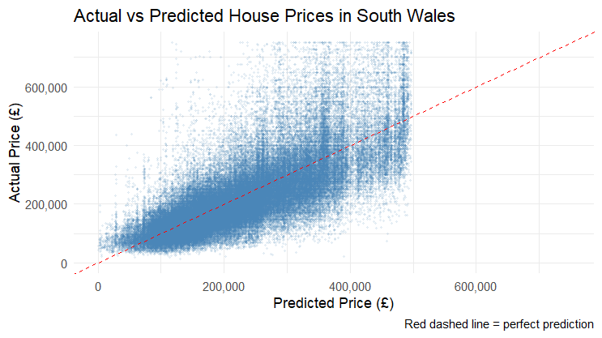
[Chart: Actual vs Predicted House Prices in South Wales]

5. Limitations
Several limitations should be noted when interpreting these findings:
- Temporal mismatch in deprivation data: The WIMD scores used are from 2019, while the house price data covers 2020–2025. Deprivation levels in some areas may have changed during this period, potentially introducing measurement error into the deprivation variable.
- Missing property-level features: The model does not have access to property size, number of bedrooms, age, condition or garden space, all of which are likely significant price drivers. This explains the remaining 47.5% of price variation not captured by the model.
- Linear model assumptions: A linear regression assumes a straight-line relationship between each variable and price. In practice, some relationships, particularly at the very high and low ends of the price spectrum, may be non-linear. A more advanced model, such as a Random Forest or gradient boosting approach, could capture these patterns.
- Outlier sensitivity: While extreme outliers were removed, the upper price limit of £2,000,000 still allows some high-value properties to influence the model, which may slightly inflate coefficients for high-demand districts like Cardiff and Monmouthshire.
- School catchment data: School rating data from Estyn were considered for inclusion but were ultimately not incorporated in this version of the analysis due to data availability constraints. It remains a strong candidate for a future extension of this work.

6. Conclusion
This analysis demonstrates that house prices in South Wales are shaped by a clear and measurable set of factors. Property type is the most powerful single driver, with detached homes commanding premiums of up to £232,000 over comparable flats. Location matters enormously; Cardiff and Monmouthshire sit at the top of the regional price hierarchy, while the former mining valleys lag significantly behind. Deprivation, as measured by the WIMD, has a strong, consistent, and statistically robust relationship with price: every step toward a less-deprived neighbourhood adds value, with the full range translating into a £113,000 differential.
The broader story these findings tell is one of a deeply divided regional housing market. A buyer in Monmouthshire's least-deprived neighbourhoods faces prices more than double those in Blaenau Gwent's most-deprived communities. While some of this gap reflects genuine differences in property stock, a significant portion reflects the compounding effects of deprivation, limited economic opportunity and historical underinvestment, factors that any serious housing policy would need to address.
Future work could extend this analysis by incorporating Estyn school inspection ratings, distance to the city centre as a continuous spatial variable, and more recent WIMD data once the 2023 index becomes widely available. A machine learning approach, such as Random Forest regression, could also be applied to test whether non-linear interactions between variables improve predictive accuracy beyond the 52.5% achieved here.

7. Technical Notes
All analyses were conducted in R using the following packages and tools:
- httr and rvest — HTTP requests and web scraping
- tidyverse — data manipulation and pipeline operations
- ggplot2 — data visualisation
- broom — model output tidying for coefficient plots
- Base R lm() — multiple linear regression
The full R script and datasets are available on GitHub. Charts were exported at 300 DPI using ggsave() for print quality. The final merged dataset contains 135,069 rows and 24 variables.

Data Sources
- UK Land Registry Price Paid Data — gov.uk/government/statistical-data-sets/price-paid-data-downloads
- Welsh Index of Multiple Deprivation 2019 — statswales.gov.wales
- ONS National Statistics Postcode Lookup (May 2025) — geoportal.statistics.gov.uk

